Automated Road Damage Detection and Crack Segmentation Using Deep Learning
The objective of this study was to compare different deep learning models for road damage detection and crack segmentation using public benchmark datasets. Seven object detection models, including YOLOv8, YOLO11, and Faster R-CNN, were evaluated on the RDD2022 dataset. U-Net and DeepLabV3+ were used for crack segmentation on the Crack500 dataset. SAHI was also tested to improve the detection of small road damages, and an ablation study was carried out to understand how different SAHI settings affect the results. The final results were compared with recent research to evaluate the performance of the proposed approach.

1. Detection Experiments
Multiple object detection architectures were trained and evaluated on the RDD2022 dataset.
Seven object detection models were trained and tested on the RDD2022 dataset. These included YOLOv8 (n, s and m), YOLO11 (n, s and m) and Faster R-CNN. The models were compared using Precision, Recall, mAP@50 and mAP@50-95.

Baseline Detection Performance
Model | Precision | Recall | mAP@50 | mAP@50-95
YOLOv8n | 0.579 | 0.516 | 0.539 | 0.285
YOLOv8s | 0.626 | 0.553 | 0.592 | 0.317
YOLOv8m | 0.677 | 0.590 | 0.633 | 0.344
YOLO11n | 0.593 | 0.514 | 0.544 | 0.287
YOLO11s | 0.613 | 0.540 | 0.575 | 0.309
YOLO11m | 0.631 | 0.546 | 0.587 | 0.314
Faster R-CNN | N/A | 0.427 | 0.536 | 0.253

Observations
- YOLOv8m achieved the best overall performance among all the tested detection models. It gave the highest Precision, Recall, mAP@50 and mAP@50-95 scores.
- In both the YOLOv8 and YOLO11 families, the larger models generally performed better than the smaller ones.
- YOLO11 models gave results close to the YOLOv8 models. During testing, they also appeared to produce fewer false detections in difficult images such as snow, vegetation and different road textures. Although this observation doesn’t hold that well with the SAHI metrics we will discuss.
- Faster R-CNN worked well as a two-stage detector but gave lower overall performance than the larger YOLO models.

2. SAHI Evaluation
SAHI (Slicing Aided Hyper Inference) was used to improve the detection of small road damages. Instead of processing the entire image at once, SAHI divides the image into smaller overlapping slices, performs detection on each slice, and then combines the results into a single prediction.

2.1 SAHI Performance
Model | Precision | Recall | mAP@50 | mAP@50-95
YOLOv8n | 0.380 | 0.285 | 0.380 | 0.186
YOLOv8s | 0.441 | 0.311 | 0.441 | 0.218
YOLOv8m | 0.484 | 0.347 | 0.484 | 0.247
YOLO11n | 0.380 | 0.277 | 0.380 | 0.184
YOLO11s | 0.421 | 0.301 | 0.421 | 0.207
YOLO11m | 0.412 | 0.301 | 0.412 | 0.203
Faster R-CNN | 0.203 | 0.271 | 0.203 | 0.086

Observations
- YOLOv8m achieved the best overall performance after applying SAHI.
- SAHI detected more road damages across all the tested YOLO models.
- The COCO evaluation also showed that SAHI introduced more false detections, which reduced Precision and mAP compared to the baseline models.
- Overall, SAHI helped detect more small road damages but came with a trade-off of increased false positives.

2.2 Detection Count Comparison
Model | Baseline Detections | SAHI Detections | Improvement
YOLOv8n | 3773 | 4564 | 20.96%
YOLOv8s | 4237 | 5475 | 29.22%
YOLOv8m | 4551 | 5321 | 16.92%
YOLO11n | 3612 | 4496 | 24.47%
YOLO11s | 4016 | 4826 | 20.17%
YOLO11m | 3986 | 4722 | 18.46%

Observations
- SAHI increased the number of detections for every YOLO model.
- YOLOv8s showed the largest improvement, with about 29% more detections.
- YOLO11n showed the highest improvement among the YOLO11 models.
- Most of the additional detections were small road damages that were missed during normal inference.

2.3 YOLO11m SAHI Ablation Study
Different SAHI settings were tested using YOLO11m to understand how confidence threshold and slice size affect the final results.
Slice Size | Confidence | Precision | Recall | mAP@50 | mAP@50-95
512 × 512 | 0.25 | 0.412 | 0.301 | 0.412 | 0.203
512 × 512 | 0.50 | 0.307 | 0.218 | 0.307 | 0.171
640 × 640 | 0.25 | 0.402 | 0.299 | 0.402 | 0.208

Observations
- The default settings (slice size = 512 × 512 and confidence = 0.25) gave the best overall balance between detection performance and the number of detected road damages.
- Increasing the confidence threshold to 0.50 reduced false detections but also reduced Recall and mAP because many correct detections were removed.
- Increasing the slice size to 640 × 640 did not improve the overall performance.
- Based on these experiments, the default SAHI settings were used for the remaining evaluations.

2.4 Overall Summary
SAHI successfully improved the detection of small road damages across all the YOLO models. However, the increase in detections also led to more false positives, which is reflected in the COCO evaluation scores. The ablation study showed that the default SAHI settings provided the best overall results, making them the most suitable choice for the remaining experiments.

3. Exploratory Evaluation of Faster R-CNN + SAHI
An exploratory study was carried out to see how SAHI performs with a two-stage detector. Unlike the YOLO models, Faster R-CNN was not one of the main models in this work, so this experiment was done to better understand the effect of sliced inference.

Experimental Results

Detection Count Comparison
Model | Images Evaluated | Baseline Detections | SAHI Detections | Improvement
Faster R-CNN | 2000 | 6899 | 11256 | 63.15%

COCO Evaluation
Model | Precision | Recall | mAP@50 | mAP@50-95
Faster R-CNN + SAHI | 0.203 | 0.271 | 0.203 | 0.086

Observations
- SAHI increased the number of detections by more than 63%.
- However, most of the additional detections were false positives or duplicate bounding boxes.
- Compared to the YOLO models, Faster R-CNN produced many more overlapping predictions after applying SAHI.
- Although Recall increased, Precision and mAP remained low because of the large number of incorrect detections.
- Based on these results, Faster R-CNN + SAHI was treated as an exploratory experiment rather than a part of the final proposed approach.

4. Crack Segmentation
Two semantic segmentation models, U-Net and DeepLabV3+, were trained and evaluated on the Crack500 dataset. The models were compared using Dice Score and IoU to measure how accurately they segmented road cracks.

Segmentation Performance
Model | Encoder | Epochs | Batch Size | Dice Score | IoU Score
U-Net | ResNet34 | 30 | 8 | 0.7533 | 0.6118
DeepLabV3+ | ResNet34 | 30 | 8 | 0.7389 | 0.5931

Observations
- U-Net achieved the best overall segmentation performance with a Dice Score of 0.7533 and an IoU of 0.6118.
- DeepLabV3+ also performed well but gave slightly lower Dice and IoU scores.
- U-Net preserved thin crack structures better in most test images, leading to cleaner segmentation masks.
- Both models were able to identify the main crack regions, but small and very thin cracks were still difficult to segment accurately.
Based on both the quantitative results and qualitative examples, U-Net was selected as the final segmentation model for this study.

5. Comparison with Recent Literature
To better understand the performance of the proposed models, the best results from this work were compared with recent studies on road damage detection and crack segmentation. Since different papers use different datasets, preprocessing methods and evaluation settings, these results should be treated as a general comparison rather than a direct ranking.

5.1 Object Detection Comparison
The best detection model from this work (YOLOv8m) and the best SAHI-based pipeline were compared with recent road damage detection methods published between 2024 and 2025.
Table 1. Comparison with recent road damage detection methods
Method | Year | Dataset | mAP@50 | mAP@50-95
RDD-YOLO | 2024 | RDD2022 | 62.5 | 36.4
Improved YOLOv8 | 2024 | RDD2022 | 65.7 | —
YOLOv8-PD | 2024 | RDD2022 | 70.6 | 39.5
YOLO-RD* | 2025 | Japan subset | 55.62 | 25.75
OBC-YOLOv8 † | 2025 | China subset | 86.0 | —
SEA-YOLOv8 | 2025 | RDD2022 | 63.2 | —
YOLOv8m (This Work) | 2026 | RDD2022 | 63.3 | 34.4
YOLOv8m + SAHI (This Work) | 2026 | RDD2022 | 48.4 | 24.7

Observations
- YOLOv8m achieved performance comparable to several recent RDD2022-based methods.
- Applying SAHI increased the number of detected road damages but reduced Precision and mAP because of additional false positives.
- Different papers used different subsets of RDD2022 and different training settings, so the results should be interpreted as a general comparison rather than a direct ranking.
Notes
- YOLO-RD was evaluated on the Japan subset of RDD2022.
† OBC-YOLOv8 was evaluated on the China subset of RDD2022.
Some papers report only mAP@50, so mAP@50-95 is not available.

5.2 Crack Segmentation Comparison
The segmentation models were compared with recent Crack500-based segmentation methods using Dice Score and IoU.
Table 2. Comparison with recent crack segmentation methods
Method | Year | Dataset | Dice (%) | IoU (%)
Pyramid Attention Network | 2020 | Crack500 | 76.81 | 62.35
Dual Flow Fusion Model* | 2023 | Crack500 | 78.10 | 66.00
Distribution-aware Noisy-label Learning | 2024 | Crack500 | 74.74 | 60.56
EGA-UNet † | 2025 | Crack500 | 77.80 | 70.00
U-Net (This Work) | 2026 | Crack500 | 75.33 | 61.18
DeepLabV3+ (This Work) | 2026 | Crack500 | 73.89 | 59.31

Observations
- U-Net achieved segmentation performance close to several recent Crack500 methods.
- DeepLabV3+ also produced good segmentation results but slightly lower Dice and IoU scores than U-Net.
- The comparison shows that the proposed models provide competitive crack segmentation performance while using standard and well-established architectures.
Notes
- The Dual Flow Fusion paper reports F1-score. For binary segmentation, F1-score is equivalent to the Dice coefficient.
† EGA-UNet reports foreground IoU, which is directly comparable to the IoU used in this work.

Overall, the literature comparison shows that the proposed models achieve competitive performance on public benchmark datasets while using simple and reproducible training pipelines. The additional SAHI experiments also provide useful insights into the advantages and limitations of sliced inference for road damage detection.

6. Qualitative Results

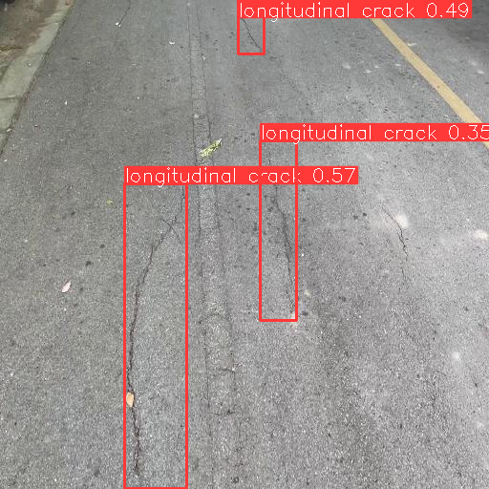
Successful Detection Example
Figure: Example showing successful road damage detection using YOLO11 + SAHI.

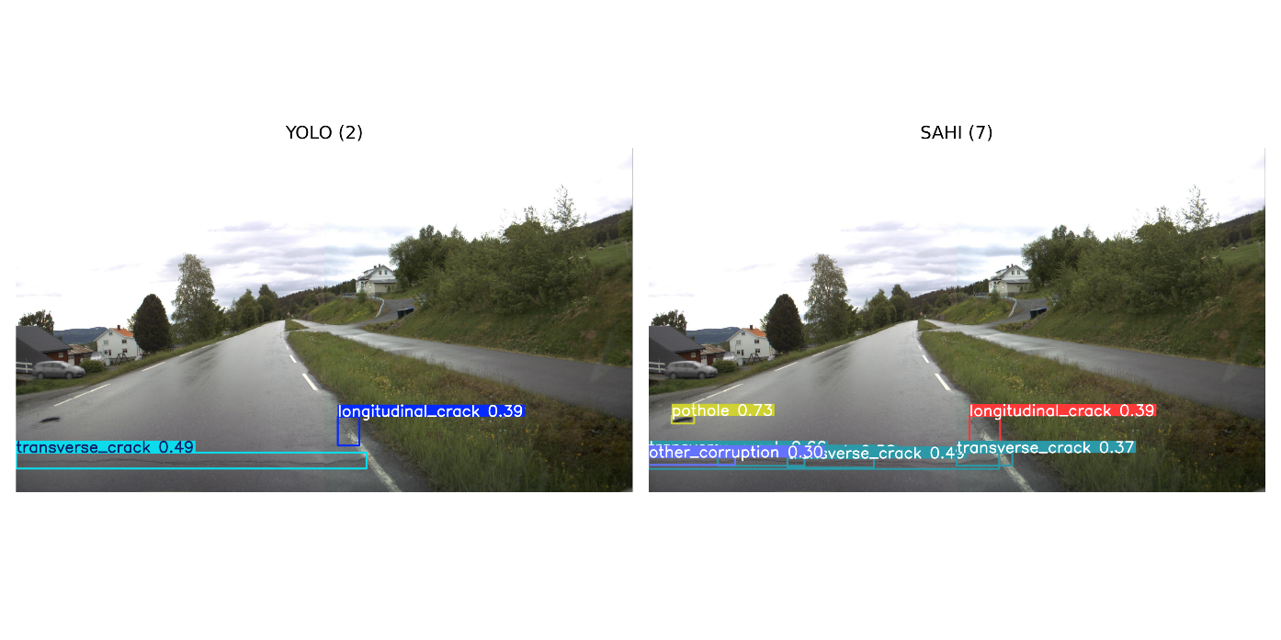
SAHI Improvement Example

Figure: Example illustrating additional small-object detections enabled by SAHI.

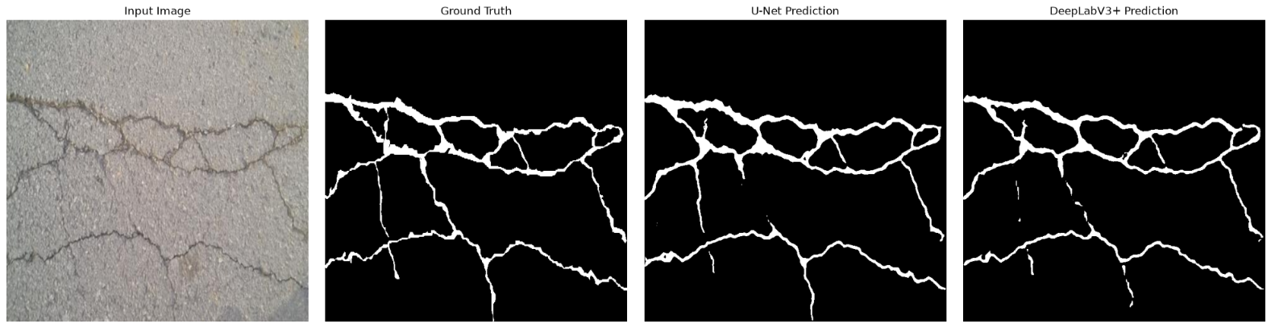
Segmentation Example

Figure: Example showing crack segmentation predictions compared with ground truth.

Failure Case Example
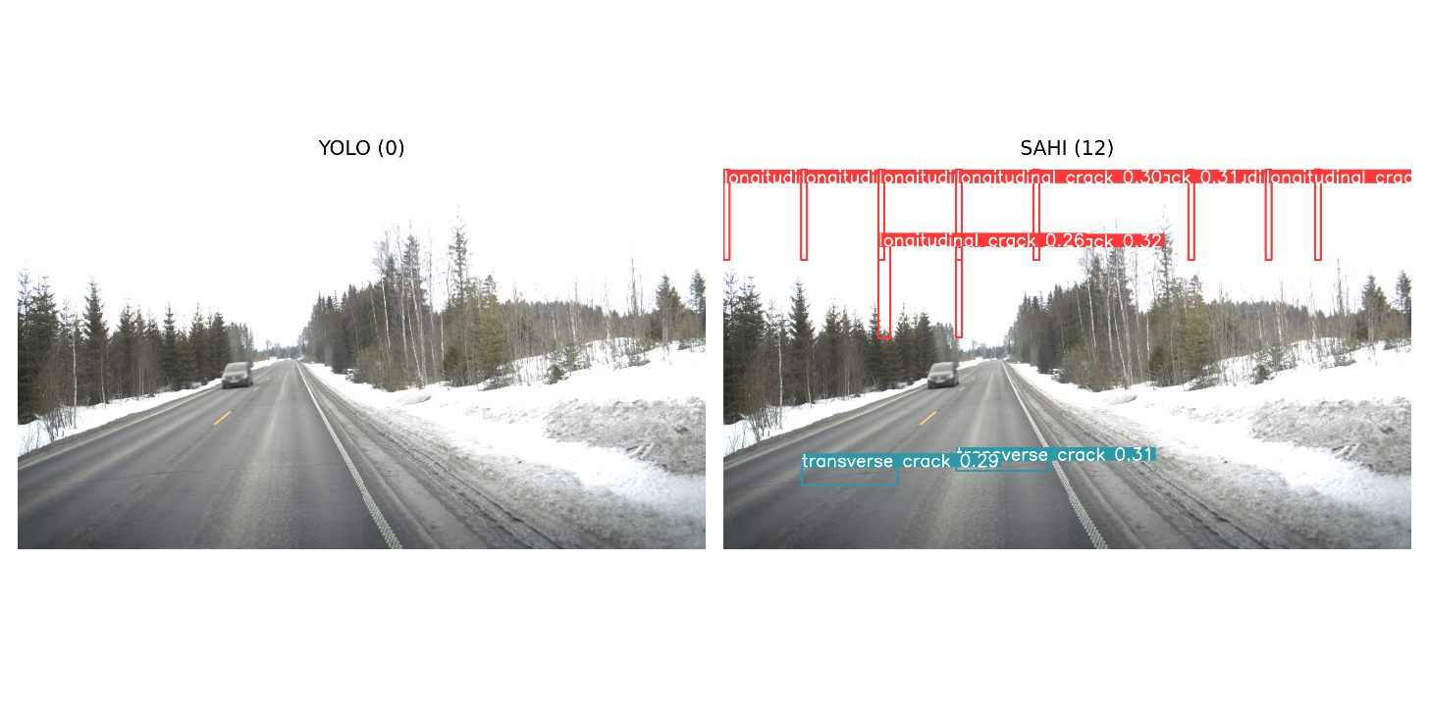
Figure: Example showing false positive detections caused by vegetation, shadows, snow-covered regions, and high-contrast road textures.

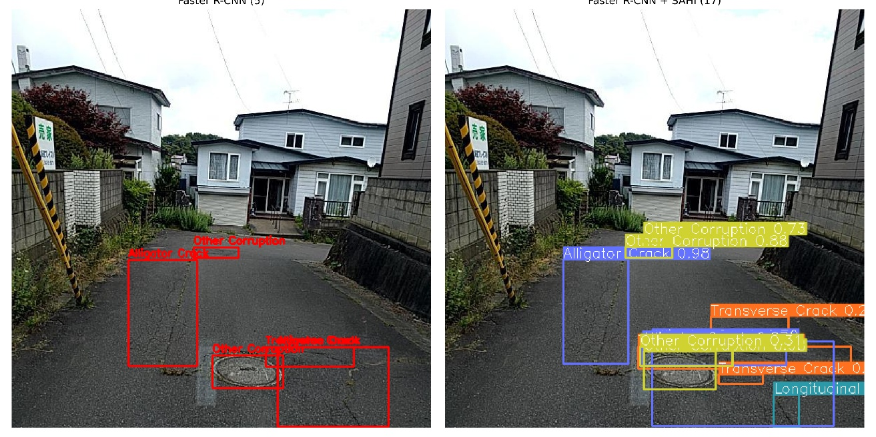
Exploratory Faster R-CNN + SAHI Example

Figure: Application of SAHI to Faster R-CNN increased the number of detected road defects but also introduced overlapping predictions, duplicate detections, and greater class confusion compared to the baseline Faster R-CNN model.

6. Key Findings
- YOLOv8m achieved the best overall detection performance among all the evaluated object detection models, with the highest Precision, Recall, mAP@50 and mAP@50-95.
- Applying SAHI increased the number of detected road damages for every YOLO model. However, the additional detections also increased false positives, which reduced Precision and mAP in the COCO evaluation.
- The YOLO11m SAHI ablation study showed that the default SAHI settings (slice size = 512 × 512, confidence = 0.25) provided the best overall balance between detection performance and false positives.
- The exploratory Faster R-CNN + SAHI experiment increased the number of detections by more than 63%, but also produced many duplicate and overlapping detections. Therefore, it was not included as part of the final proposed approach.
- For crack segmentation, U-Net achieved better Dice Score and IoU than DeepLabV3+, making it the best segmentation model in this study.
- The comparison with recent literature showed that the proposed detection and segmentation models achieved competitive performance on the RDD2022 and Crack500 benchmark datasets.
- Common failure cases included vegetation, shadows, snow-covered roads, lane markings and complex road textures, which often resulted in false detections or missed road damages.
- Overall, YOLOv8m was selected as the final object detection model, while U-Net was selected as the final crack segmentation model. SAHI proved to be an effective method for improving small-object detection, although it introduced additional false positives that should be considered during deployment.

7. References
[1] D. Arya, H. Maeda, S. K. Ghosh, D. Toshniwal, and Y. Sekimoto, "RDD2022: A Multi-national Image Dataset for Automatic Road Damage Detection," Scientific Data, vol. 9, Art. no. 315, 2022.
[2] F. C. Akyon, S. O. Altinuc, and A. Temizel, "Slicing Aided Hyper Inference and Fine-Tuning for Small Object Detection," Proc. IEEE International Conference on Image Processing (ICIP), pp. 966–970, 2022.
[3] S. Ren, K. He, R. Girshick, and J. Sun, "Faster R-CNN: Towards Real-Time Object Detection with Region Proposal Networks," Advances in Neural Information Processing Systems (NeurIPS), vol. 28, 2015.
[4] Z. Cai and N. Vasconcelos, "Cascade R-CNN: Delving into High Quality Object Detection," Proc. IEEE/CVF Conference on Computer Vision and Pattern Recognition (CVPR), pp. 6154–6162, 2018.
[5] K. He, G. Gkioxari, P. Dollár, and R. Girshick, "Mask R-CNN," Proc. IEEE International Conference on Computer Vision (ICCV), pp. 2961–2969, 2017.
[6] Z.-Q. Zou, K. Chen, Z.-W. Shi, Y.-H. Guo, and J. Ye, "Object Detection in 20 Years: A Survey," Proceedings of the IEEE, vol. 111, no. 3, pp. 257–276, 2023.
[7] C.-Y. Wang, A. Bochkovskiy, and H.-Y. M. Liao, "YOLOv7: Trainable Bag-of-Freebies Sets New State-of-the-Art for Real-Time Object Detectors," 2022.
[8] R. Khanam and M. Hussain, "YOLOv11: An Overview of the Key Architectural Enhancements," 2024.
[9] Y. Li, C. Yin, Y. Lei, J. Zhang, and Y. Yan, "RDD-YOLO: Road Damage Detection Algorithm Based on Improved You Only Look Once Version 8," Applied Sciences, vol. 14, no. 8, Art. no. 3360, 2024.
[10] Y. Jiang, "Road Damage Detection and Classification Using Deep Neural Networks," Discover Applied Sciences, vol. 6, Art. no. 421, 2024.
[11] J. Zeng and H. Zhong, "YOLOv8-PD: An Improved Road Damage Detection Algorithm Based on YOLOv8n Model," Scientific Reports, vol. 14, Art. no. 12052, 2024.
[12] W. Wang, X. Yu, B. Jing, Z. Tang, W. Zhang, S. Wang, Y. Xiao, S. Li, and L. Yang, "YOLO-RD: A Road Damage Detection Method for Effective Pavement Maintenance," Sensors, vol. 25, no. 5, Art. no. 1442, 2025.
[13] S. Zhang, Z. Liu, K. Wang, W. Huang, and P. Li, "OBC-YOLOv8: An Improved Road Damage Detection Model Based on YOLOv8," PeerJ Computer Science, vol. 11, e2593, 2025.
[14] Y. Zhao, B. Shi, X. Duan, W. Zhu, L. Ren, and C. Liao, "Research on Road Surface Damage Detection Based on SEA-YOLOv8," PLOS ONE, vol. 20, no. 6, e0324439, 2025.
[15] O. Ronneberger, P. Fischer, and T. Brox, "U-Net: Convolutional Networks for Biomedical Image Segmentation," Proc. MICCAI, pp. 234–241, 2015.
[16] L.-C. Chen, Y. Zhu, G. Papandreou, F. Schroff, and H. Adam, "Encoder-Decoder with Atrous Separable Convolution for Semantic Image Segmentation," Proc. European Conference on Computer Vision (ECCV), pp. 801–818, 2018.
[17] S. L. H. Lau, E. K. P. Chong, X. Yang, and X. Wang, "Automated Pavement Crack Segmentation Using U-Net-Based Convolutional Neural Network," IEEE Access, vol. 8, pp. 114892–114899, 2020.
[18] X. Yang et al., "Convolutional Neural Network-Based Pavement Crack Segmentation Using Pyramid Attention Network," Computer-Aided Civil and Infrastructure Engineering, 2020.
[19] X. Wang et al., "Dual Flow Fusion Model for Concrete Surface Crack Segmentation," Automation in Construction, 2023.
[20] H. Zhang et al., "Distribution-aware Noisy-label Learning for Crack Segmentation," 2024.
[21] H. Wang et al., "EGA-UNet: An Efficient Semantic Segmentation Method for Road Crack Detection," 2025.

